|  |  |
| --- | --- |
| C:\Users\sbs\Downloads\university logo.png | **SHAHEED BHAGAT SINGH STATE UNIVERSITY, FEROZEPUR** |

Ref No: SBS/FZR/COE/spl-01                       Date: 08/06/24

**PROCEDURE FOR EXAMINATION FORM FILLING IN HOD LOGIN**

***Admit Cards for regular students should not be created for students who have left the University. Therefore, the data of such students must be deleted from the database through COE office.***

Regular and reappear Examination Forms are to be filled at <https://sbsexam.edu.in>

1. **Filling of Regular Examination Forms**

The Admit Cards are to be created in the HOD Logins only. The following is the stepwise procedure:

1. Login at <https://sbsexam.edu.in> using HOD Login credentials.
2. Go to **Department → Students Group**. Select appropriate **Program** and **Batch**. Student list will be displayed. Change the **Groups** for the students wherever required and click **Update Groups**.
3. Please do confirm that students have uploaded their proper PP Size photos and last column in the table shows locked status.
4. If photo not available, ask the student to update his/her profile. Lock the student profile.

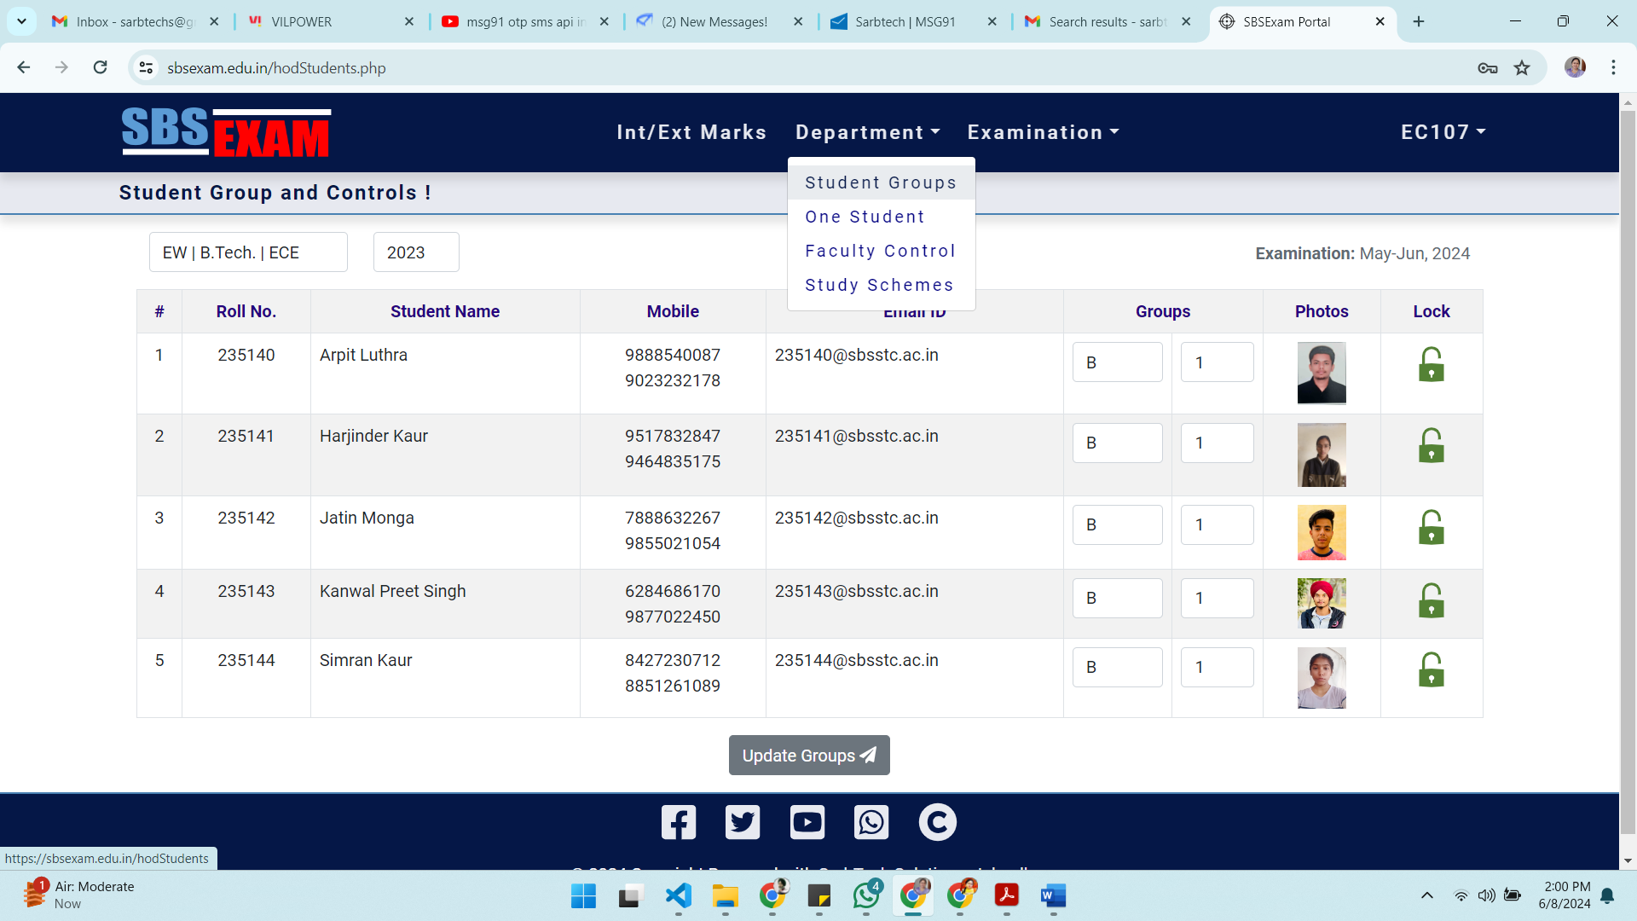

1. Go to **Examination → Compulsory Courses**. Select required **Program** and **Batch | Sem**. A list of compulsory courses will be populated.

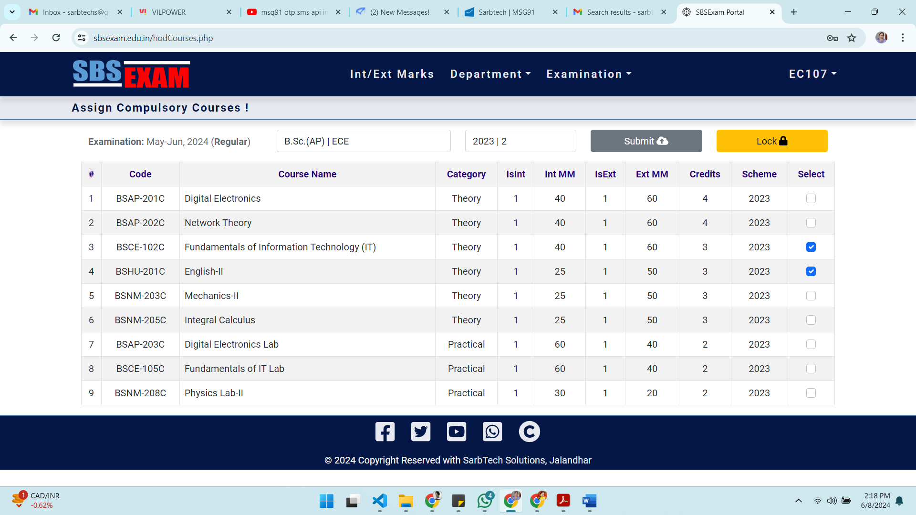

1. In case number of students in batch is less than equal to 30 and the number of compulsory subjects is up to 10, **select all the required compulsory courses** at a time and click **Submit**.
2. Otherwise, for number of students more than 30 and/or number of subjects are more than 10, then
   1. **Select the compulsory courses in pairs** and then click **Submit**.
   2. Wait for the process to complete (Do not lock).
   3. Now uncheck already submitted courses. Select the next two courses and click **Submit**. Wait for the process to complete.
   4. Repeat these steps (a. to c.) to submit all the compulsory courses in parts. At the end of the completion of the process all the required courses must be checked as shown.

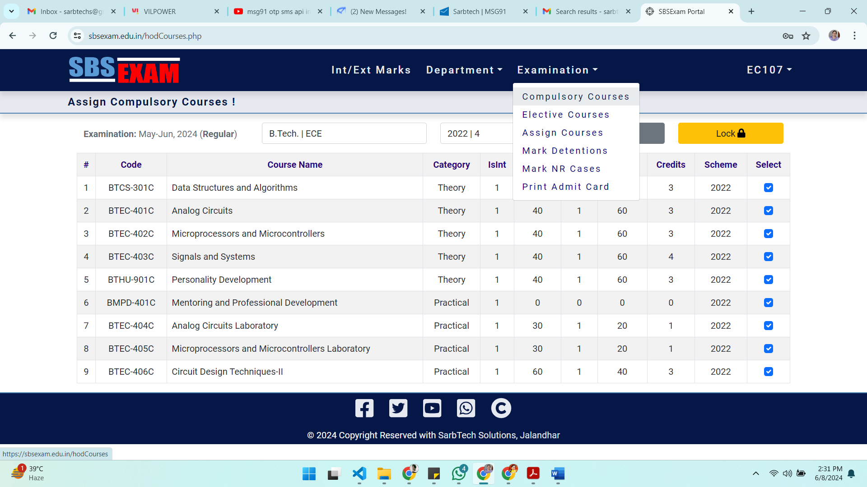

1. Click the **Lock** button to finally lock compulsory courses.
2. Go to **Examination → Elective Courses**. Select required items from **Programs**, **Batch | Sem** and **Electives** dropdowns.
3. Select opted elective course from available list of courses for each student.

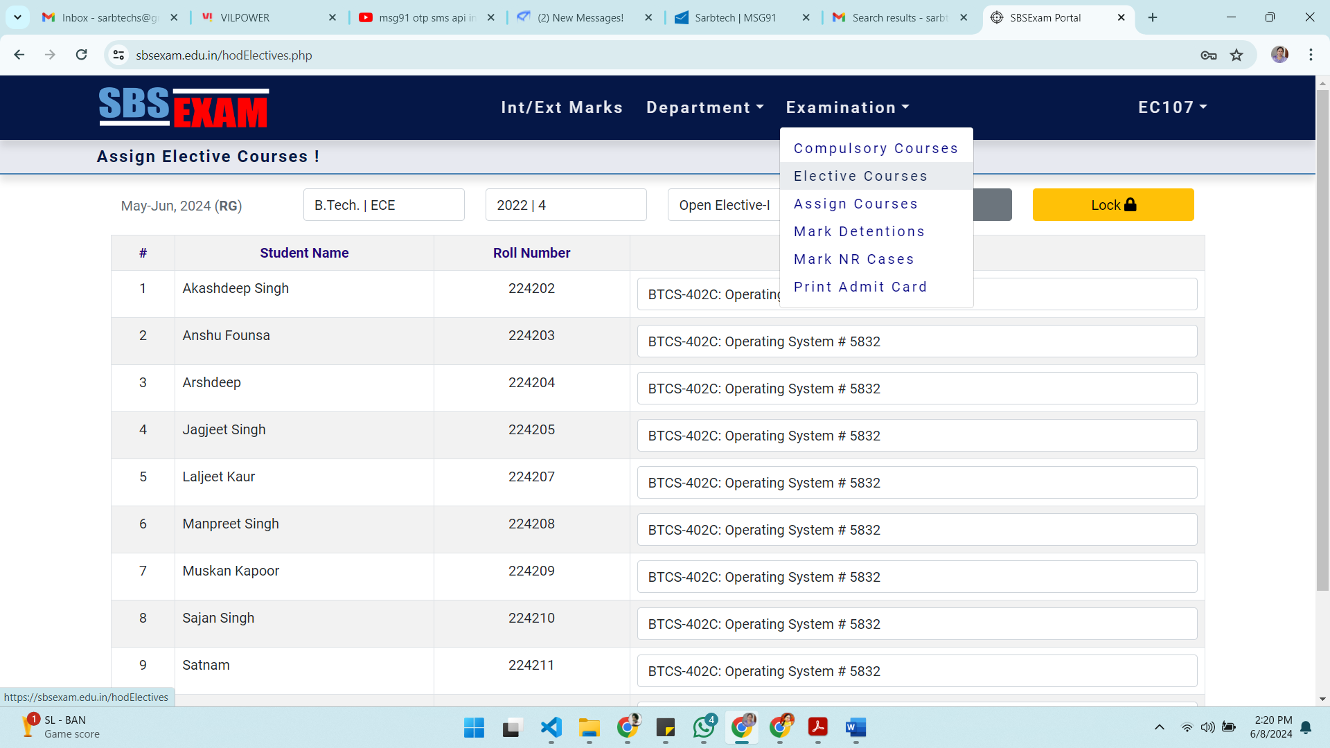

1. Repeat, if the number of elective courses is more than one.
2. Finally, click the **Lock** button to lock assignment of Elective Courses. **Kindly ensure that each student is allocated the correct elective subject.**
3. HOD are then required to mark the detentions. Go to **Examination → Mark Detentions**.Select required from **Exams**, **Programs**, **Sem** and **Courses** dropdowns. Mark tick in detention checkbox wherever required and click **Save & Lock** button (Click **Save Only** button only for temporary save; Need to be locked later on).

1. Repeat these steps to mark and lock detentions in all courses.
2. **Locking of detention is required even if no one is detained in any course**.
3. Go to **Examination → Mark NR Cases** to confirm Not Registered cases. Select required from **Programs** and **Batch | Sem** from top dropdowns. Mark tick in the checkbox for required Not-Registered case(s). Click **Save & Lock** button to finally confirm locking of NR Cases.

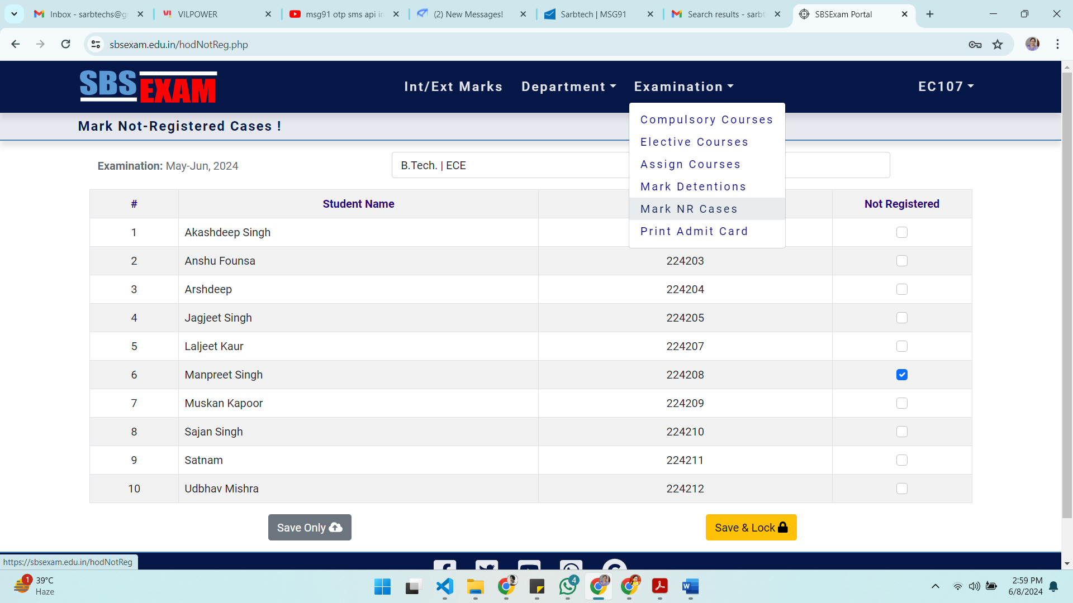

1. Go to the option **Examination → Print Admit Cards**. Select required **Exams** (as RG), **Programs** and **Batch | Sem** from dropdowns. A list of created Admit Cards for regular students will be displayed. Take print out and distribute to students.

***In case of reappear cases, the department must check subjects filled and verify the Examination Fee Receipt before locking the reappear Examination Form. Then the reappear Admit Cards can be printed.***

1. **Filling of Reappear Examination Forms**

The Reappear examination forms have to be filled by the concerned students at <https://sbsexam.edu.in> through their Student Logins. After submitting and locking RP Form, the student will approach to the department office with a receipt of Reappear Examination Fee paid by him/ her for the RP Admit Card.

1. Login into HOD Login with the given credentials.
2. Go to **Examination → Print Admit cards**.Select required **Exams** (as RP), **Programs** and **Batch | Sem** from dropdowns
3. A list of submitted and locked examination forms will be displayed with the details of **Fee+Fine** Amount, **Receipt No.**, **Dated** and **Status** (unlocked). Match the data with the fee receipt provided by the student and click **Lock** button. Once locked, the RP Admit Card of that student can be printed.
4. **Student Profile**

***The basic student data like name, father’s name, Roll Number and authorized email ID are locked. In case any change is required for these basic credentials, the student should be asked to contact DCOE (C&S) with an application through the department.***

1. Login into HOD Login with the given credentials.
2. Go to **Department → One Student**.
3. Enter the roll number. The profile data is displayed with password.
4. The profile may be locked/ unlocked as required.

-sd-

**Controller of Examination**

**CC:**

* Registrar
* Dean Academics/ DSW
* All HODs
* University website